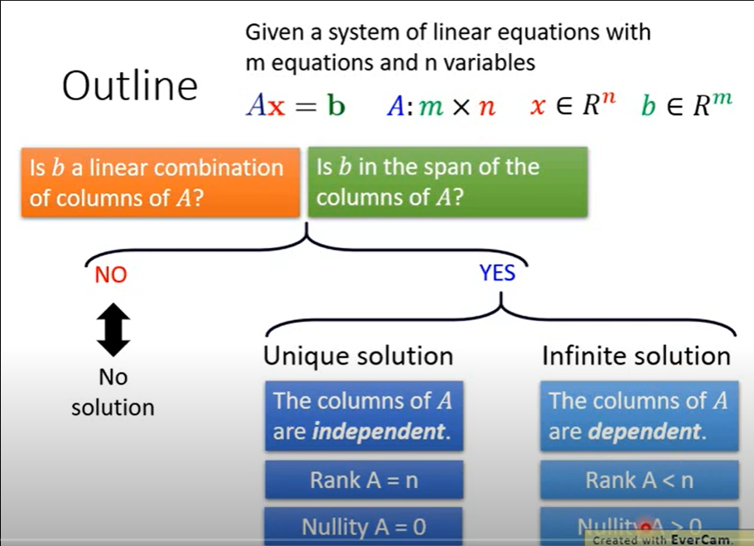

- Zero vector is the linear combination of any other vectors
- Any set contains zero vector would be linear dependent

Given a vector set, {a1, a2, , an}, there exists scalars x1, x2, , xn, that are not all zero, such that x1a1 + x2a2 + + xnan = 0.
>只要x有任何一組非0的解，該線性方程式即為相依
在有解的前提下，相依的線性方程式有無窮多組解
只要 Ax=0 有非0解 ，此線性方程式有相依性
(*大小A表矩陣、小寫x表純數向量)

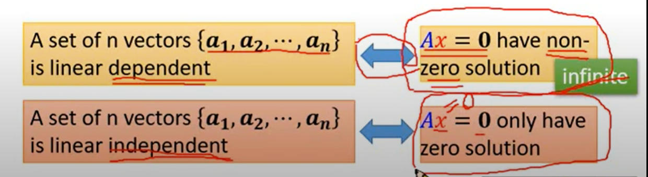

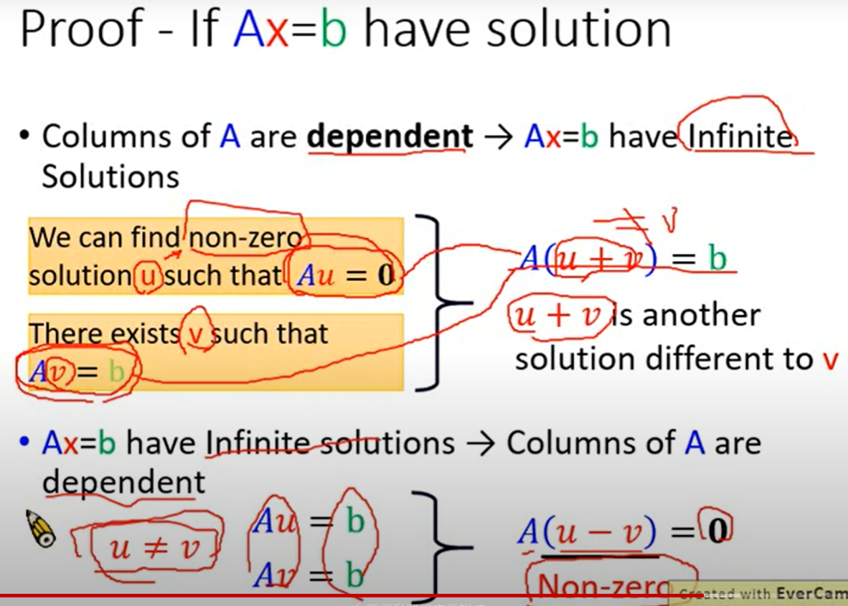

Rank & Nullity

Rank: The rank of a matrix is defined as the maximum number of linearly independent columns in the matrix. 為整數

Nullity = Number of columns - rank
